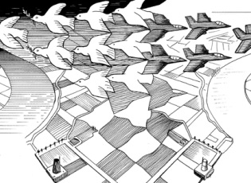
CARTOON CONTEST
Both Slovenia and the Netherlands are committed to the peaceful settlement of international disputes, guaranteeing human rights, good relations with other states, international law, and lasting peace. The city of The Hague is known as the city of Peace and Justice: the International Criminal Court, the International Court of the United Nations, the OPCW, and the iconic Peace Palace are all housed in this city.
But what do YOU, young people and the ambassadors of tomorrow, know about this in practice? How are YOU involved in the complicated concept of international law? And how can YOU make their own contribution to the promotion of peace and justice?
In this contest, YOU get to work. We ask for your ideas about local solutions that can contribute to international justice. You can submit your thoughts in the form of tweets, sketches, comments and photos, and our cartoonists will turn them into professional cartoons.
How does it work?
- You have this great idea about Peace and Justice, that brings it right down to the essence.
- You make a sketch of your own idea for a cartoon. Or you tweet your thoughts through Twitter. Or you express your idea in the form of a photograph.
- Next, you load your sketch/tweet/picture to the Cartoon Movement online newsroom (www.cartoonmovement.com/newsroom) – no later than 15 Sept.2014
- There, more than 300 professional political cartoonists from all over the world can see your sketch/tweet/picture. It inspires them and they turn it into a ‘real’ cartoon, which they upload. You get the credit for the idea.
- They share the cartoon with their friends, you with yours. On Facebook and Twitter. It becomes the starting point of a good discussion!
- all young people – students, PhD-students etc. – can participate.
- For a nice explanation and the relevant links, see:
http://www.cartoonmovement.com/project/28
http://www.youtube.com/watch?v=SMmTctrhYrQ
At the end of the project, the ten best cartoons will be selected by an international jury. These will be displayed at the Peace Palace in The Hague, in the week of September 21, 2014, the International Day of Peace.
This project is a collaboration in Slovenia between the Netherlands Embassy and the Law Faculty of Ljubljana University. It is meant to make the issues of international peace and justice more visible and interesting to the young people. And to put the city of The Hague on the map as the global center of expertise for peace and justice.

